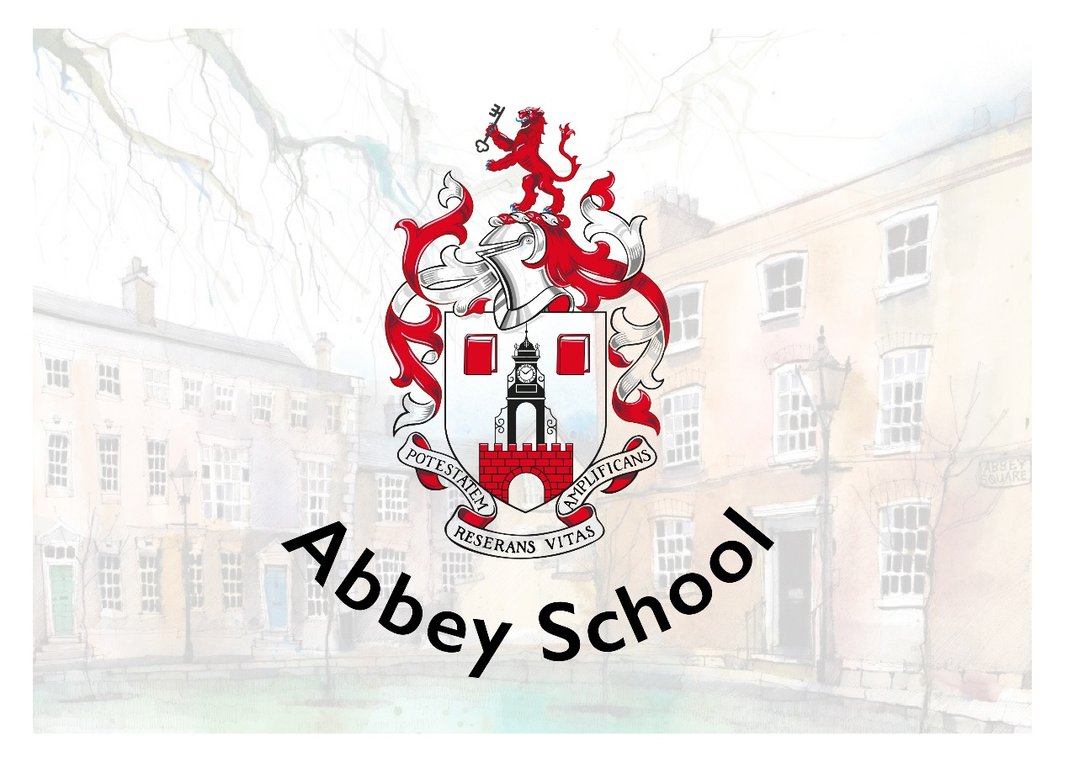

RECRUITMENT PACK
EYFS Phase Lead

Abbey School
10-12 Abbey Square
Chester, CH1 2HU
recruitment@abbeyschool.com
01244 960000

CONTENTS

Welcome from the Principal 3
About our School 4
Job Description & Person Specification 6
Benefits 11
How to Apply 12
Shortlisting and Interviews 12
Start Date 12
Safeguarding Statement 12
Equal Opportunities Statement 12
Working in Chester 13

Welcome from the Principal

Welcome and thank you for your interest in Abbey School.
Our Independent Special School provides a unique environment of high-quality, evidence-informed education, nurture and care to young people aged 4-19 with autism whom may have additional learning difficulties and behaviours that challenge. We offer a comprehensive programme of support which ensures that all of our pupils’ individual needs are met through highly personalised learning.
We are privileged to benefit from a truly wonderful location. Our school is housed in stunning Grade II* listed buildings, part of historic Abbey Square in the heart of the beautiful city of Chester. Our fantastic team of architects have designed a well-equipped and high-tech learning environment for us, whilst maintaining the beauty of the buildings and surroundings for our pupils to enjoy. We make full use of our environment and location with a creatively designed curriculum that includes focused learning and enrichment activities that support wellbeing. This enables all of our young people to experience growth, development and success.
Our highly skilled and specialist staff team includes teachers, learning and behaviour specialists, speech and language therapists and occupational therapists. This trans-disciplinary focus ensures that each pupil’s individual needs are understood, accurately planned for and closely monitored as part of day-to-day school practice.
I am extremely proud to be the Principal of Abbey School, a place where pupil-centred practice is the norm and where the voice of the young people we support and their families is central to all that we do. It really is a very special place to work and learn.
Yours sincerely
Dr. Katy Lee

About our School
Abbey School is an Independent Special School for people aged 4-19 with autism whom may have additional learning difficulties and behaviours that challenge. We provide high-quality education and care in our beautiful Grade II* listed buildings in the heart of Chester. All young people attending Abbey School have an Education, Health and Care Plan (EHCP) with school places commissioned and funded via local authorities. We work in close partnership with families and carers with support, information sharing and workshop opportunities available throughout the academic year.
Abbey School is aspirational for all of the young people that we support. This aspiration is captured in our vision, mission and values which are central to all that we do at Abbey School.
Vision
Our vision is that all children with exceptional needs receive a meaningful and fulfilling education that enables them to make their own choices about the direction of their adult lives.

Mission
Abbey School exists to provide the best education possible for young people with exceptional needs.
- Every pupil is a unique individual with potential
- Special educational needs and/or disability should not be a barrier to a valued lifestyle
- All children and young people without exception are entitled to access the best education and support available
- Best practices in education are evidence-based
- Teaching and learning decisions should be evidence-driven
- Clear goals make data-based decisions more numerous and effective
- Education is for everyone and for the whole of a person’s life
- Learning is enabling, empowering and extends the boundaries of autonomy
- If a pupil is not learning, it is the teaching that needs to change – the learner is always right
- Pupil voice should be heard and respected

Values
Our whole school approach brings together everything that is known from special education research and best practice to maximise pupil learning and wellbeing. We are an innovative learning organisation. Our day-to-day working practices routinely inform research, evaluation and development. We have a bespoke curriculum, designed by us, specifically to meet the needs of our pupils.

Each pupil’s journey through the curriculum is personalised. Approaches to teaching and learning are individualised, goal-based and precisely assessed. The curriculum is delivered by transdisciplinary teams who benefit from a high level and intensive internal training programme.

Our unique APPs support staff in planning and monitoring each pupil’s learning journey on a moment-to-moment basis. We are centrally located in the heart of the city which provides many opportunities for community-based learning, live skills development and supported work placements as young people get older.

Every decision we make is framed in the context of the Abbey School BAGS model:
B – Belonging and connection – being part of a community and having a network of valued relationships.
A – Autonomy and control – having influence over day-to-day and life defining matters.
G – Gifts and talents – doing even better the things that are done really well, and learning to do things that are important but may not be done at all.
S – Speaking, listening and a sense of self – communicating effectively in a variety of ways not just speech, and having an identity that defines who I really want to be.

Job Description & Person Specification
Job Title | EYFS Phase Lead | Team | Abbey School
Salary | MPS / UPS + TLR | Reporting to | Assistant Principal
Working Hours | 35 hours per week  (Maternity Cover) | Line Manages | Teachers in phase

The Phase Lead will join our dynamic middle management team. This is a non-class-based leadership and management role.

Role Purpose
- Contribute to the overall leadership and day-to-day operational management of Abbey School with specific responsibilities identified and agreed with the Assistant Principal.
- Further the aims of the school and support the SLT in ensuring that the vision and ethos of the school is communicated and upheld.
- Share with the SLT a responsibility for providing quality assurance in all the school’s activities.
- Provide the SLT with an overview of major school issues through ranging awareness and contact with staff and pupils.

Responsibilities and Role
Leadership and Management
- Directly manage class teachers within the phase and conduct annual appraisals, discussing the individual progress of staff, setting targets, and ensuring that professional standards remain high.
- Maintain regular informal contact with staff, e.g. monthly one-to-ones, to ensure any issues are addressed, situations de-escalated and timely support put in place where necessary.
- Contribute to establishing the core values of the school and assist with making management decisions on all aspects of policy, development and organisation by playing a significant role in the preparation, implementation and monitoring of the SDP.
- Oversee all aspects of the phase’s leadership team to ensure that school policies and practices are being delivered and implemented consistently.
- Assist with planning timetables and rotas for pupils and ensure staff are deployed effectively and proportionately across the phase.
- Contribute to the management of key school events.
- Support, lead, motivate and liaise with staff within the phase to ensure that provision is effective and adjustments are made as necessary to help staff meet their personal and professional targets.
- Advise and support class teachers with the leadership and management of support staff within the phase, acting as a role model to ensure the highest standards are delivered at all times.
- Work with the SLT to ensure that individual staff accountabilities are clearly defined, understood and agreed and are subject to review and evaluation.
- Acknowledge, share and promote excellence and develop effective team working.
- Assist line managers to identify and support staff requiring a Performance Improvement Plan (PIP) and liaise with SLT and HR regarding staff on PIPs.

Staffing, Recruitment and Retention
- Support the recruitment manager in recruiting and inducting staff in the phase, ensuring safeguarding procedures are adhered to during the recruitment process.
- Work with the Training Lead to ensure that all staff access effective induction and opportunities for continuing professional development which are linked to staff appraisal.
- Support the staffing coordinator with matters relating to whole school staffing needs.
- Support with the implementation of the school’s sickness absence management plan for staff within the phase.
- Manage requests from staff within the phase for absence and leave according to the school’s Absence and Leave Policy.

Monitoring and Evaluation
- Work with the SLT to ensure that the aims, values and objectives of the school are achieved through an effective School Development Plan.
- Support the SLT in the monitoring and evaluation of the School Development Plan.
- Assist the SLT in identifying school needs by a process of school self-evaluation.
- Monitor the quality of teaching and learning, including conducting lesson observations and monitoring of planning and scrutiny of pupils’ work, ensuring that the appropriate action plans are in place when issues are identified.
- Develop a clear knowledge of the administrative and financial matters related to Abbey School and to work with the Deputy Principal and School Business Manager to manage aspects of the budget under the Phase Lead’s responsibility.
- Meet with the SLT on a regular basis to discuss matters of policy, organisation and development.
- Work with the SLT in analysing performance, progress and attainment data for the school resulting in school wide targets for improvement.
- Support in the evaluation of the Abbey School curriculum, enrichment and opportunities for pupils.
- Quality assure key documentation including annual review paperwork, lesson planning, curriculum assessments, PLPs / TLPs, daily communications with families and end of year reports to parents, to ensure appropriate breadth and balance of curriculum based on the individual needs of pupils in phase.

Curriculum Planning
- Support the development of policies, procedures, systems and processes to monitor, evaluate and review teaching and learning at Abbey School.
- Liaise with the curriculum lead and subject leaders concerning subject choices and implementing a broad and balanced curriculum.
- Ensure the curriculum is engaging and accessible for all, in line with the Equality Act 2010.
- Ensure the school curriculum, timetable and staffing model supports personalised curricula and equality of opportunities for all pupils in the phase.
- Provide clear and effective leadership of the Abbey School Model in collaboration with the SLT.
- Work collaboratively with the SLT to ensure that robust Assessment for Learning and the Abbey School Model underpins and informs teaching and learning across the school.
- Oversee the planning and coordination of whole school events within the phase as part of the global learning calendar.

Pupil Progress and High Expectations
- Support in the implementation of a clear model for pupil progress reviews through conducting regular pupil progress meetings with teachers within the phase to ensure appropriate breadth, balance and access to the curriculum for all pupils and to hold teachers accountable for the progress of all pupils across the phase, ensuring that appropriate intervention is in place for pupils of concern.
- Ensure that colleagues hold consistently high expectations for all pupils and have effectively planned targeted, personalised support to ensure that pupils achieve their targets.
- Work with the SLT to identify pupils who are not making effective progress and coordinate the staff team supporting these pupils to create an action plan.
- Ensure that pupils’ success and achievement is celebrated and promoted throughout school life through various initiatives such as celebration events.
- Plan, allocate, support and evaluate the work undertaken by all departments within the phase, ensuring staff receive the support required to successfully deliver the curriculum.
- Monitor academic progress in the phase and ensure pupils receive a suitable level of support.
- Use assessment data to inform analysis of individual pupil progress and progress within the phase.
- Ensure staff within the phase can identify any pupil underperformance as soon as possible and support staff with implementing any changes to improve the pupil’s attainment.
- Identify barriers to learning and ensure these are minimised and overcome, where possible.
- Liaise with teachers and other school staff, e.g. TDT, regarding pupils’ needs and ensure any additional support required is accommodated for.

Reporting and Recording Pupil Progress
- With the SLT, to further develop policies, systems and processes for monitoring and reporting pupil progress and outcomes to all stakeholders.
- Facilitate multi-disciplinary agency working in school.
- Report on the phase’s attainment to the SLT.

Behaviour, Safety and Wellbeing
- Direct matters relating to pupil behaviour and welfare to the appropriate member of the TDT or SLT.
- Work with the SLT to ensure that the needs of all pupils are considered at all stages of planning in the school.
- Support staff with the production of risk assessments for community visits and trips and provide approval of risk assessments at the EVC level.

Professional Development
- Commitment to developing a clear knowledge of the Abbey School Model (ASM) and the evidence-based approaches that underpin it.
- Keep abreast of current educational research and policy and ensure that it is integrated into the practice at Abbey School where appropriate and in agreement with the SLT.
- Take a full and active part in professional development activities.
- Regularly attend any relevant training and development activities both within and outside school and to attend relevant meetings.
- Keep up to date with the requirements of the Department for Education, Ofsted, the Independent Schools Standards.

Common Accountabilities and Dimensions within all Roles
- Demonstrate the vision and values of Abbey School in everyday practice, upholding the schools’ ethos at all times.
- Actively contribute to the culture of Abbey School as a learning organisation
- Be responsible for ensuring that your own practice is consistent with Abbey School policies and procedures.
- Be responsible for your own effective professional communication, orally and in writing, to the right people at the right time.
- Be responsible for ensuring that your own responsibilities and accountabilities are clearly defined and understood and for managing your work and working proactively with your line manager to that end.
- Uphold Abbey School policies to protect and safeguard pupils and vulnerable adults in order to secure their health, safety and wellbeing.
- Ensure that any personal care offered to pupils maintains their dignity, promotes their independence and account of all relevant policies.
- Be responsible for ensuring that personal use of resources is efficient and effective and actively upholds Abbey Schools’ policies.
- Assume personal responsibility for implementing the schools’ policy on Equal Opportunities and inclusion for all staff and pupils.
- Support the SLT in the day-to-day operational management of the school to ensure it meets the needs of all site users, including pupils, staff, parents and visitors and supports effective teaching, learning and support.
- Undertake any reasonable task in line with requirements of the role under the direction of the Principal / Deputy Principal.
- This role is subject to an Enhanced DBS with barred list checks

Phase Lead Person Specification
Qualifications and training
Essential | Desirable
- Qualified teacher status  - 2:1 degree in relevant subject  - Willing to undertake further training | - Post-graduate qualification  - SEND qualification  - Specialist training or further study in Early Years education.  - Middle leadership qualification e.g. NPQSL
Skills and experience
Essential | Desirable
- Experience leading, monitoring and reviewing curriculum areas across EYFS  - Experience of evaluating and improving provision  - Work effectively with vulnerable pupils  - Liaise with a range of agencies and professionals to support pupils with complex needs  - Effective communication with parents | - Recent experience in a leadership role within a SEND setting  - Show how resources, including staffing resources, can be managed and developed effectively  - Experience managing a team
Knowledge
Essential | Desirable
- Strong understanding of the needs of pupils with complex SEND  - Demonstrate a strong understanding of the EYFS curriculum and statutory framework.  - Demonstrate different teaching methods and how teaching should be adapted to cater for pupils’ varying needs  - Show a sound understanding of relevant legislation (including safeguarding legislation) and educational developments | - Strong understanding of school guidance and legislation  - Demonstrate knowledge of the AET Framework
Leadership Skills
Essential | Desirable
- At least 2 years in a leadership role within a school setting  - Successful leadership experience within Early Years Foundation Stage.  - Ability to lead and inspire the EYFS team, modelling high-quality practice  - Ability to monitor and evaluate teaching, the learning environment, planning and assessment  - Ability to plan and lead EYFS meetings, briefings and professional development  - Capacity to drive improvement in curriculum, provision and outcomes  - Strong organisational skills and ability to manage day-to-day operations of the phase | - Experience contributing to whole-school improvement planning
Personal Qualities
The successful candidate will be…
- Highly organised
- A good communicator
- Able to manage performance with sensitivity and understanding
- Able to use their own initiative
- Able to work well as an individual and as part of a team
- Able to motivate themselves and those around them
- Approachable, empathetic and personable
- Calm under pressure
- Physically and emotionally resilient

Benefits
- Competitive salary
- Suite of staff benefits including pension scheme
- Technology appropriate for your job
- Comprehensive staff training programme
- Access to WeCare which is a 24/7 online GP, mental health support service, get fit programme and much more.
- Access to MediCash program for wellbeing benefits
- The opportunity to shape and improve the life chances of pupils with a disability, and in so doing, extend the prospect of an improved quality of life for family members and others

How to Apply
If you feel like you have the right qualities to join our exciting, innovative and exceptional school then please complete the school application form with a letter addressed to the Deputy Principal, Ms Kelly Holloway. Please ensure that you provide details of your skills and experience necessary for this particular position in your letter or personal statement. Application forms and letters can be emailed to recruitment@abbeyschool.com or sent by post to Abbey School, 12 Abbey Square, Chester, CH1 2HU. Please note that we only accept fully completed application forms.
Deadline
Thursday 26th March

Shortlisting and Interviews
Selection methods will be objective, promote equality of opportunity and guard against bias in line with the Equality and Diversity policy. The School will shortlist applicants based on the relevance and applicability of their professional attributes and personal qualities specified by the role. Essential and desirable qualities are published in the Person Specification for this role.
The School will complete an online search for all shortlisted candidates. If any incidents or issues have happened that are publicly available online, the school may wish to explore this at interview.
The interview will consist of a formal panel interview, an in-tray task on the interview date (one hour), and a 15-minute class observation (no preparation necessary).

Start Date
While our preferred start date is June 2026, we will also consider a September 2026 start for the right candidate.

Safeguarding Statement
Abbey School is committed to safeguarding and promoting the welfare and safety of all pupils and expects all staff and volunteers to share this commitment.
Applicants will be required to undergo child protection screening appropriate to the post, including checks with past employers and the Disclosure and Barring Service.
The safeguarding responsibilities of this post are to uphold Abbey School policies to protect and safeguard pupils and vulnerable adults in order to secure their health, safety and wellbeing.
The post is exempt from the Rehabilitation of Offenders Act 1974 and the School is therefore permitted to ask job applicants to declare all convictions and cautions (including those which are ‘spent’ unless ‘protected’ under the DBS filtering rules) in order to assess their suitability to work with children.
Our Safeguarding Policy can be found on our Policies page on our website.

Equal Opportunities Statement
We are an equal opportunities employer and welcome applications from all suitably qualified persons regardless of their age, disability, gender reassignment, race, sex, pregnancy and maternity, marriage/civil partnerships, religion/belief, or sexual orientation.

Working in Chester
Abbey School is situated in the beautiful surroundings of Abbey Square, located in the heart of historic Chester.
Chester has often been ranked as one of the best places to live in the UK with many good schools, thriving suburbs, a vibrant independent restaurant scene and new, award-winning cultural centre Storyhouse. It has good rail and motorway connections to major cities and the coast.
Chester is suitable for families and singles or couples with a good choice of city-centre accommodation and villages or suburbs within close commuting distance. To find an Estate Agent for sales or lettings in Chester visit Best Estate Agent Guide.
For further information about living in Chester, please visit the Tourist Information website .
How to Find Us
We are located in Abbey Square next to Chester Cathedral, off Northgate Street.
By Public Transport
We promote sustainable travel and recommend that public transport is used where possible. Chester train station is a 5-10 minute walk away and is served by the following rail companies Merseyrail, Avanti West Coast, Transport for Wales and Northern Rail. For Park and Ride information visit the Cheshire West and Chester council information page.
Parking
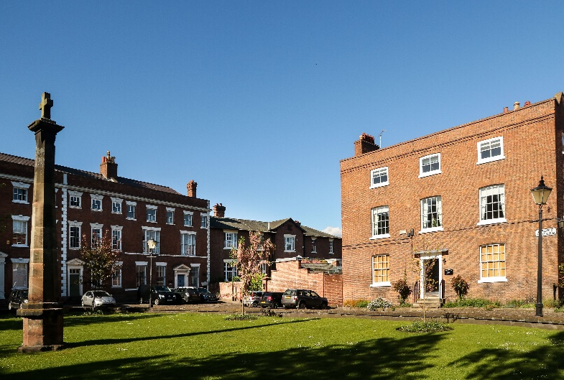
Visit the tourist information site for details of city centre car parks.

